|  |  |  |  |  |  |
| --- | --- | --- | --- | --- | --- |
| Date | …. | | | Tester Name | Alyssa Johnson |
| Environment | Penfax - Test | | | Login used |  |
| Operating System | Select OS | Version: | Update: | | |
| Software Used | Select Software | Version: | Update: | | |
| Select Software | Version: | Update: | | |
| Release version | 22.3.0 | | | | |
| Title | E23.13 | | | | |
| Test Type | Regression | | | | |
| Test Scenario | Interfund Transfer Letters | | | | |
|  |  | | | | |
| Expected Results | Verify the batch run successfully and letters generated and saved on member communications and visible on PLANet member  Member list for test cases:   * PEPP and VPB member * VPB member with changing specified fund order * PEPP and VPB member with two funds & doing rebalance * PEPP and VPB member in PEPP steps * PEPP and VPB member moving part of their funds to specialty (from asset allocation) | | | | |
| Pass/Fail | Pass | | | JIRA# | N/A |

|  |  |  |  |
| --- | --- | --- | --- |
| **SID** | **Last Name** | **Member search criteria/scenario** | **Outcome** |
| 132307 | Veidenheimer | PEPP, Active or Deferred, (charge fee) | Letter on comm, mentions fee, shows interfund and DAI change |
| 256776 | Velasquez | PEPP two funds (rebalance) | Letter ok, super confusing but has all the information it should. In comm. |
| 314161 | Venne | PEPP move partial from Asset allocation to specialty | Letter good, in comm. |
| 310963 | Velkoska | PEPP in PEPP steps | In communications tab, and on PlaNet – letter good. |
| 260043 | Venn | VPB, Active | Plan VPB is visible on letter, on PlaNEt and in comms tab, letter good. |
| 187447 | Hildebrand | VPB, two funds | Letter good, visable on planet and comm. |
| 252402 | Wormsbecker | VPB, specified fund order | Letter good, transfer in $$ worked correctly, viewable both spots |
| 313042 | Vey | VPB in PEPP steps | Letter good. |
| 285226 | Vetter | VPB moving partial from asset allocation to specialty | Letter good. |

Venne:

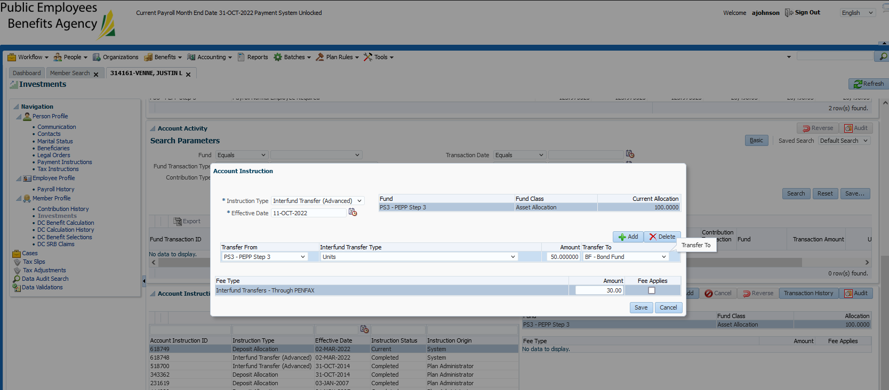

Velkoska:

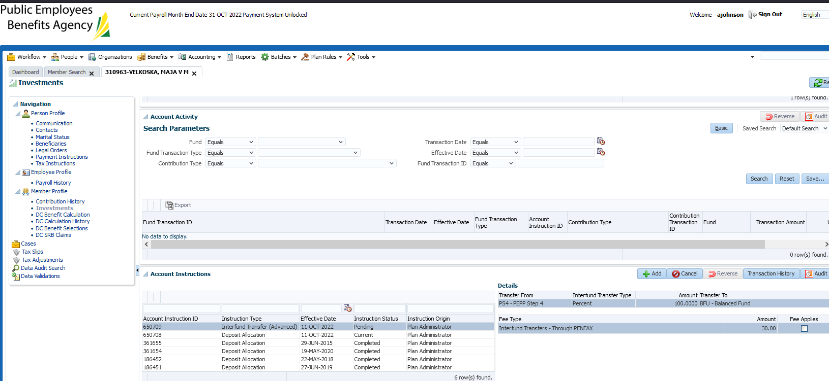

Velazquez:

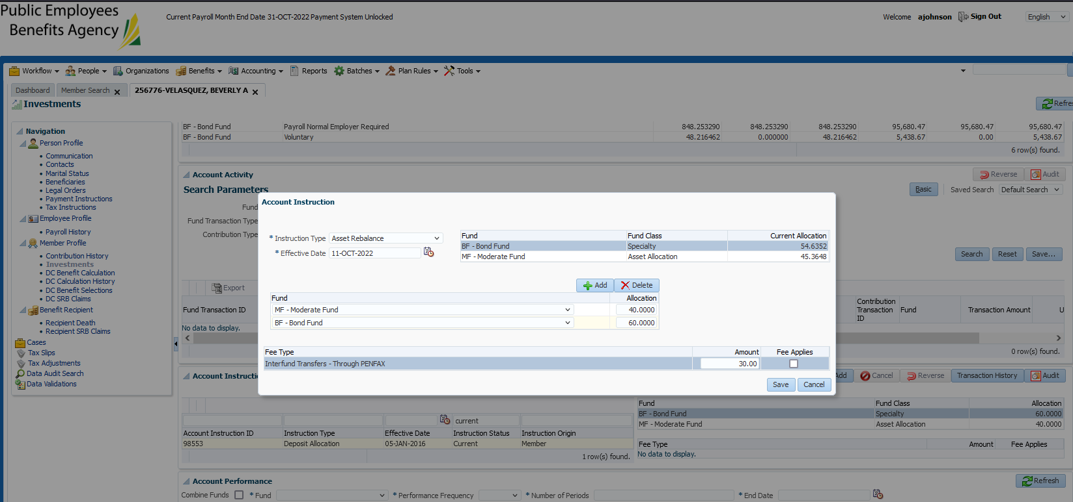

Veidenheimer:

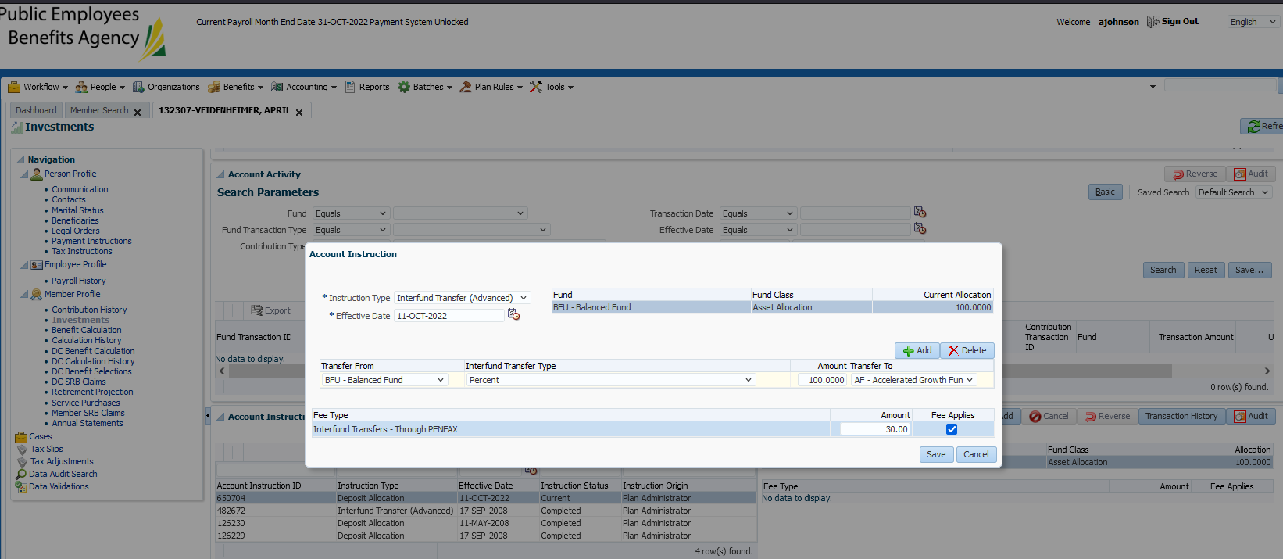

Wormsbecker:

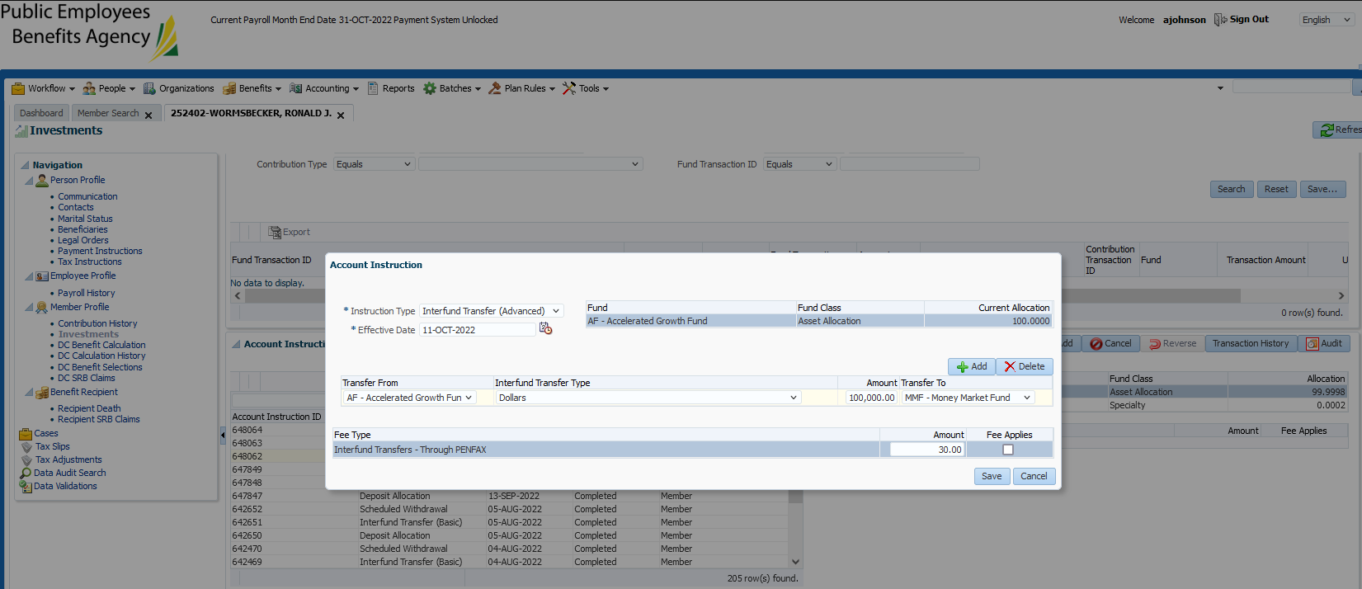

Vey:

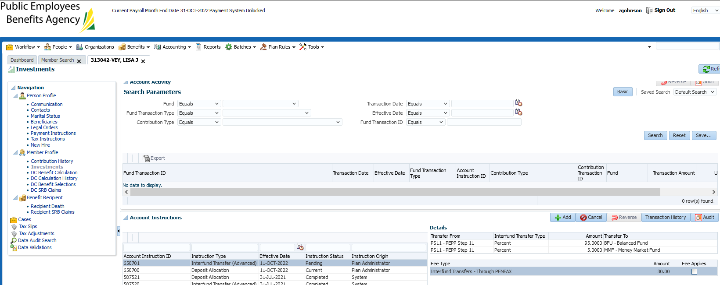

Vetter:

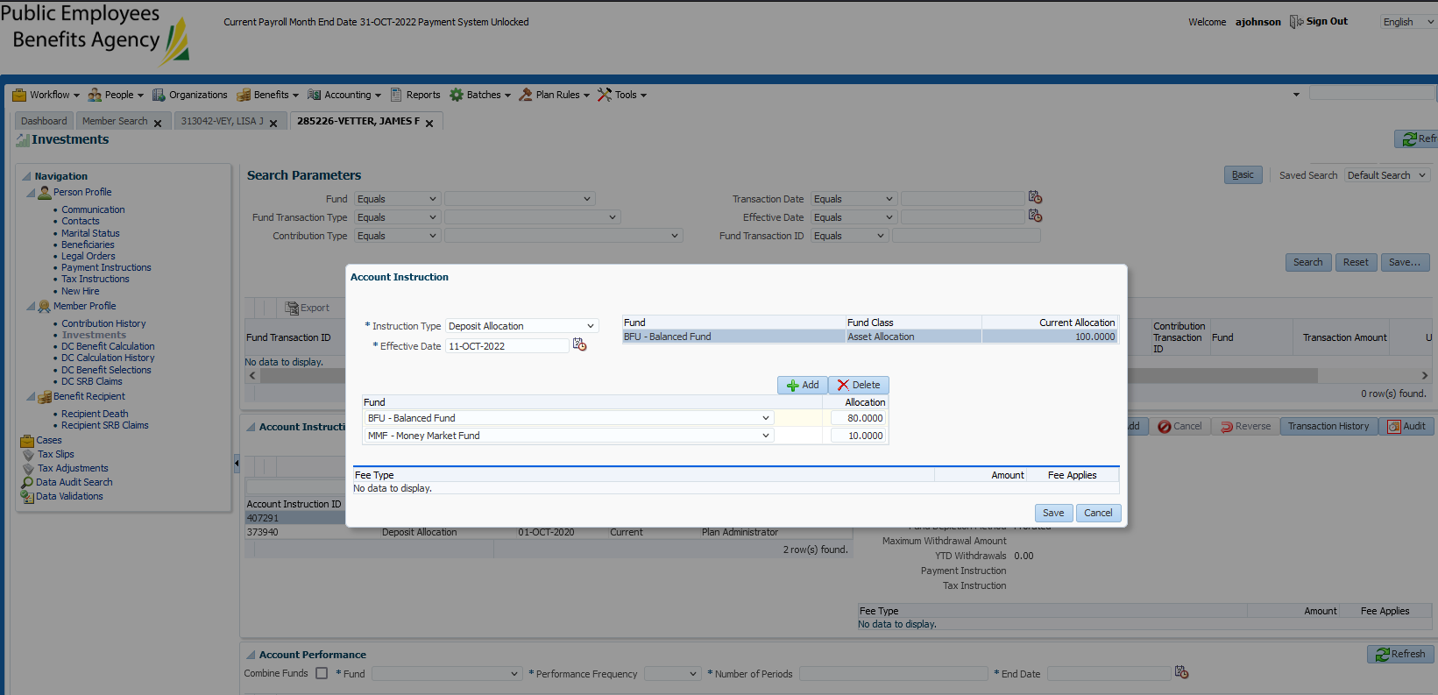

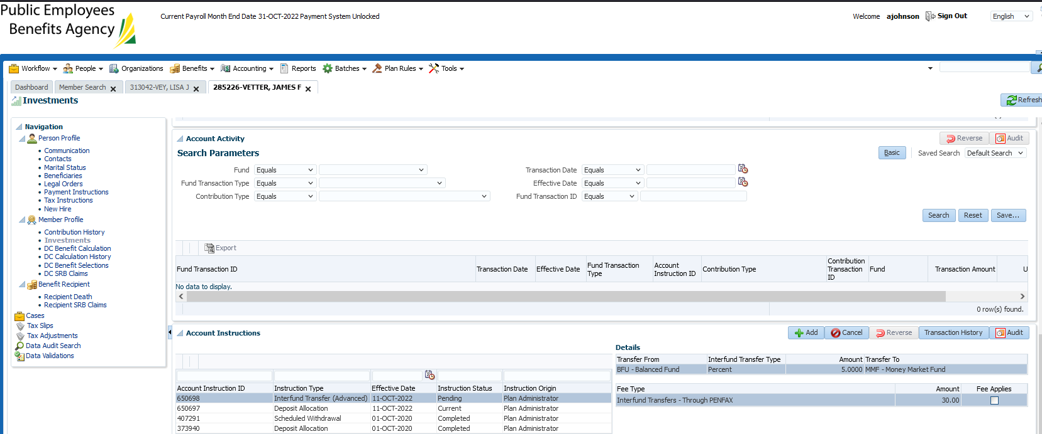

Venn:

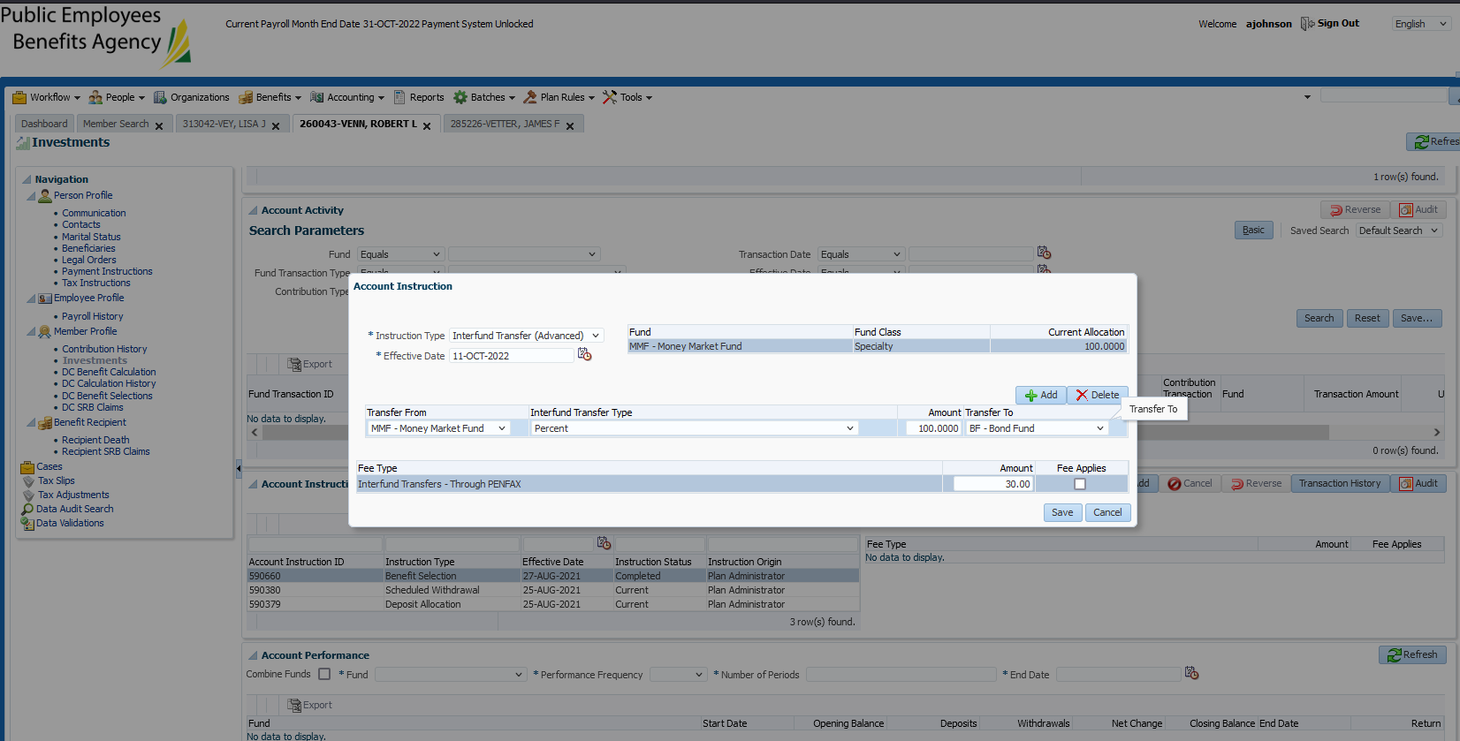

Hildebrand:

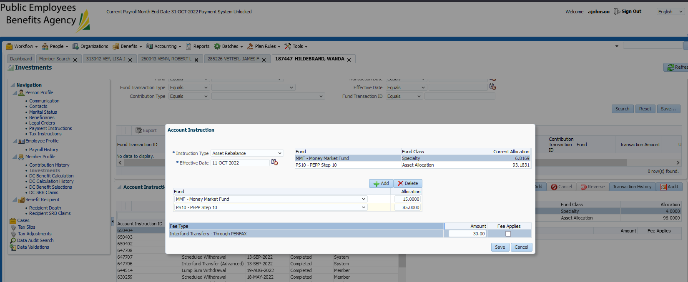

Batch ran successfully (automatically overnight):

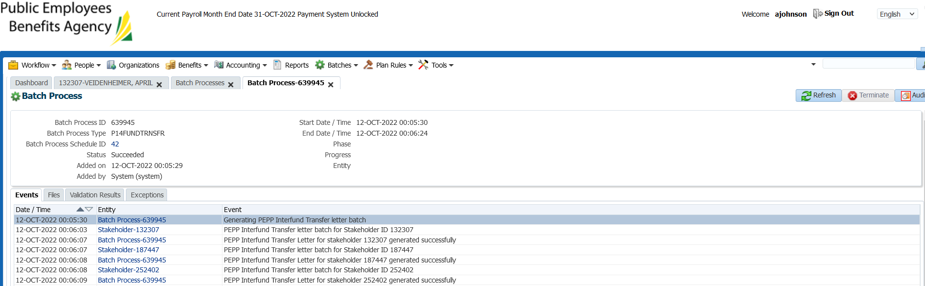

Confirming that all my interfunds that I processed generated a letter:

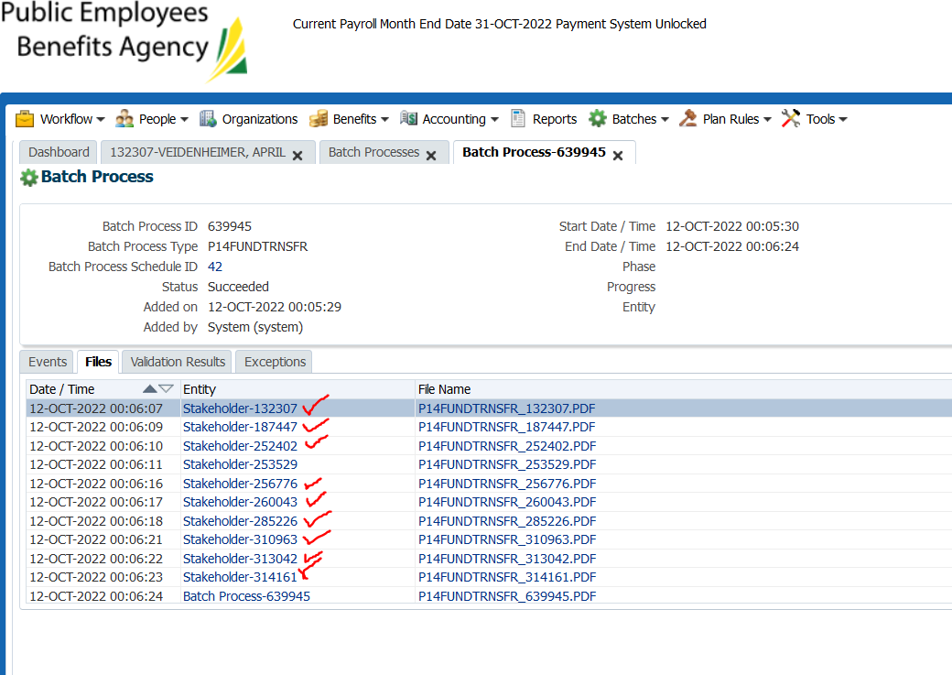

Confirming letter details and visibility on communications tab in planet (written in the chart at the top of this test case).